Supplementary data

A quantum assessment of the interaction between Si₁₂C₁₂, BSi₁₁C₁₂, BSi₁₂C₁₁, NSi₁₁C₁₂ and NSi₁₂C₁₁ nanocages with Glycine amino acid: A DFT, TD-DFT and AIM study

M. Rezaei-Sameti*¹, M. Barandisheh Naghibi
¹*Department of Applied Chemistry, Faculty of Science, Malayer University, Malayer, 65174, Iran

Figure S1 The bond length and bond angle Si₁₂C₁₂ nanocage before and after Al and N doped
Model IV | Model III | Model II | Model I | Pristine
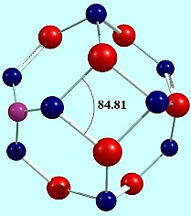 | 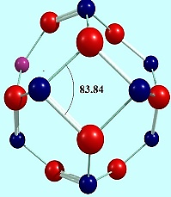 | 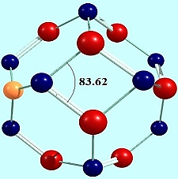 | 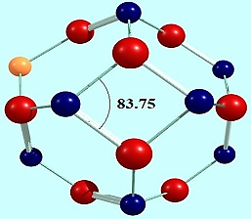 | 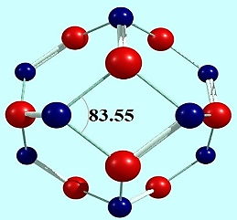
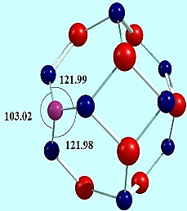 | 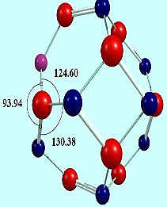 | 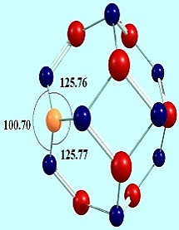 | 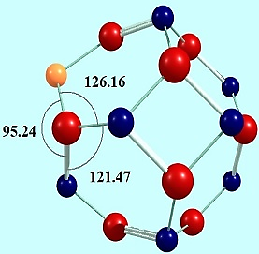 | 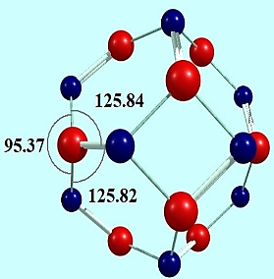
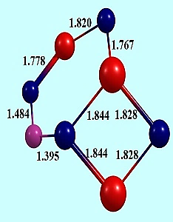 | 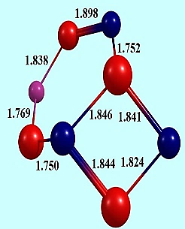 | 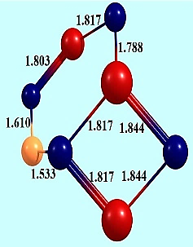 | 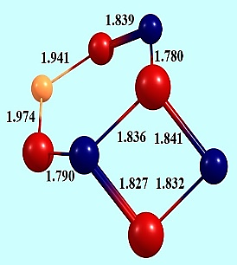 | 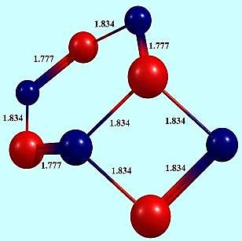

Figure S2 The bond length and bond angle Si₁₂C₁₂ nanocage and distance between Glycine and nanocage at A-a to F-c models.
Distance between nanocluster and glycine | Angle bond | Length bond
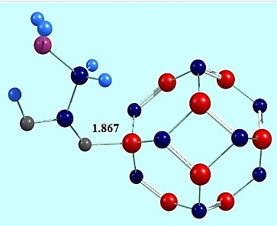 | 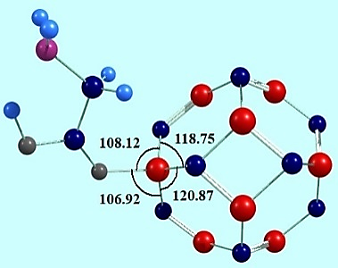 | 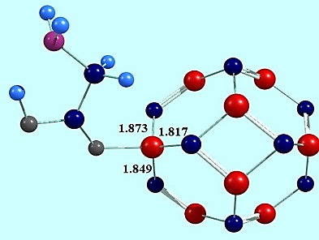 | MODEL A-a
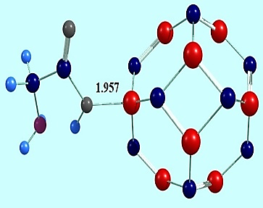 | 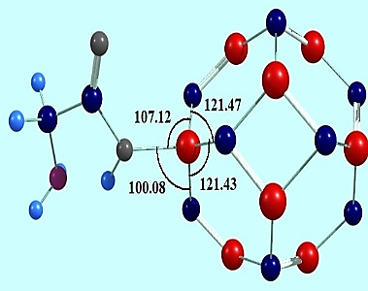 | 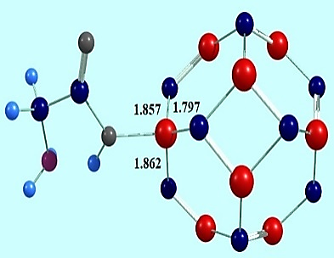 | MODEL A-b
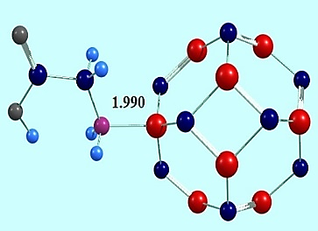 | 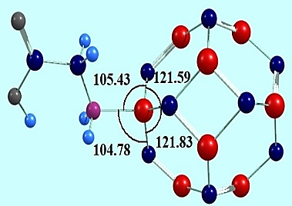 | 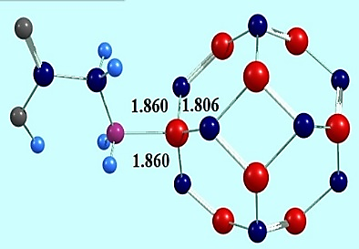 | MODEL A-c
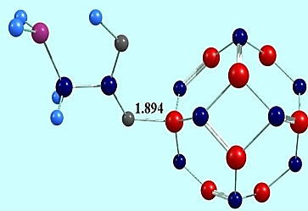 | 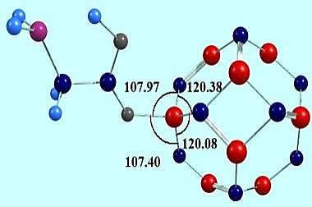 | 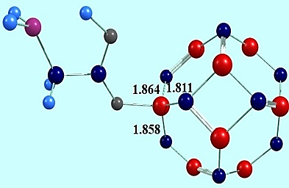 | MODEL B-a
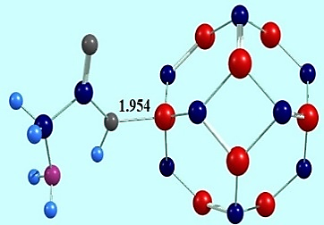 | 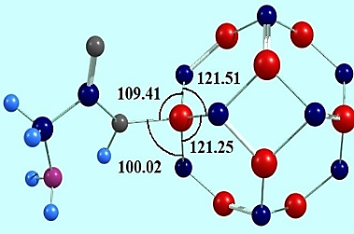 | 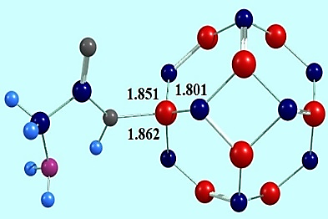 | MODEL B-b
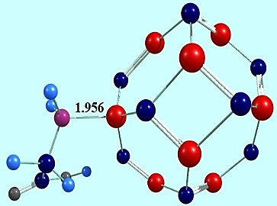 | 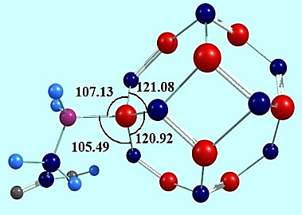 | 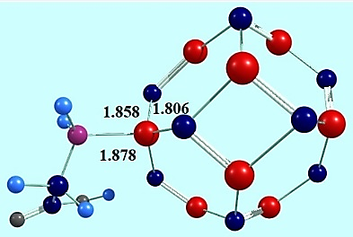 | MODEB B-c
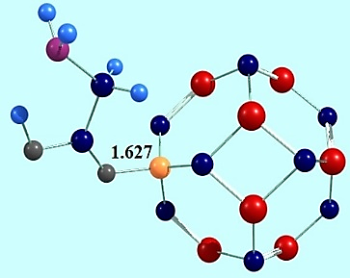 | 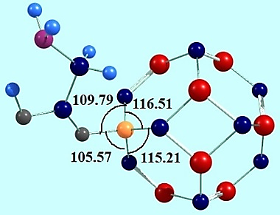 | 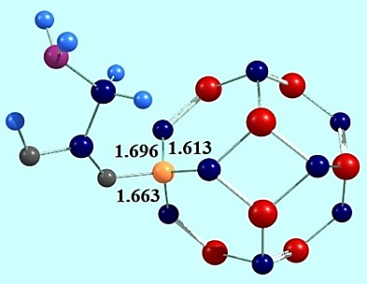 | MODEL C-a
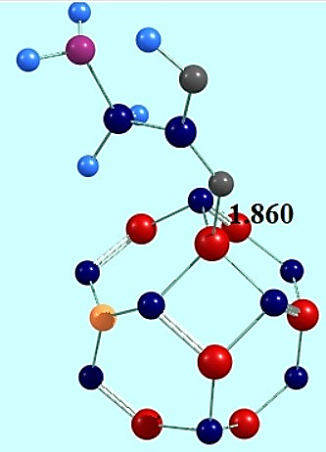 | 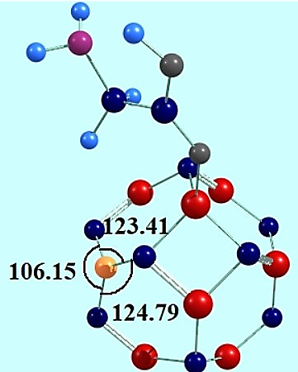 | 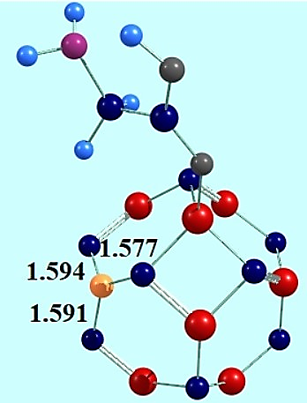 | MODEL C-b
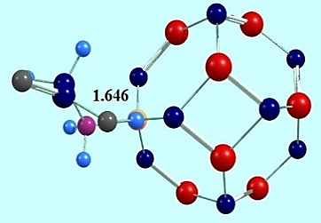 | 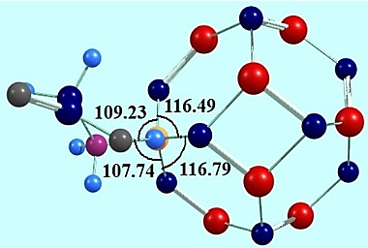 | 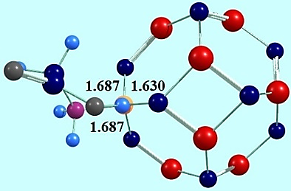 | MODEL C-c
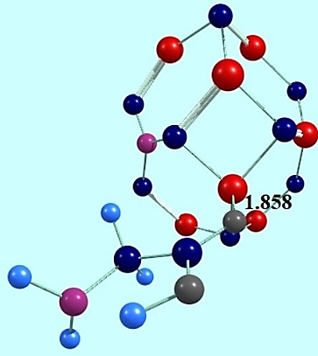 | 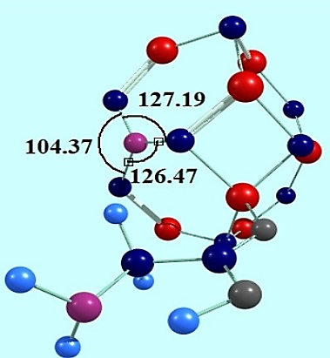 | 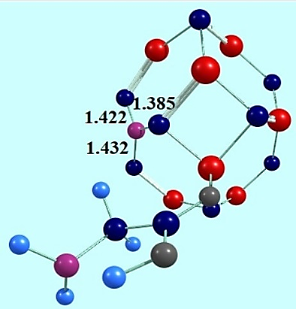 | MODEL D-a
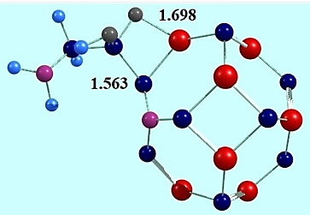 | 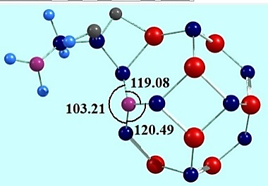 | 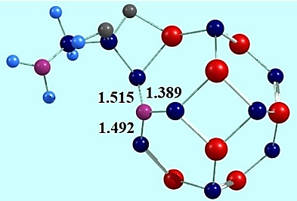 | MODEL D-b
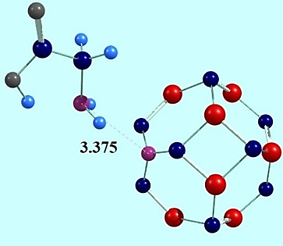 | 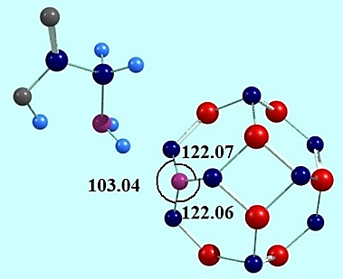 | 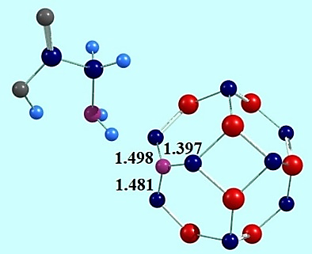 | MODEL D-c
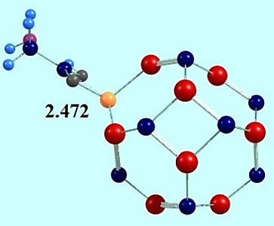 | 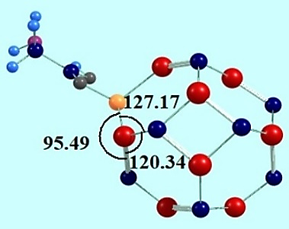 | 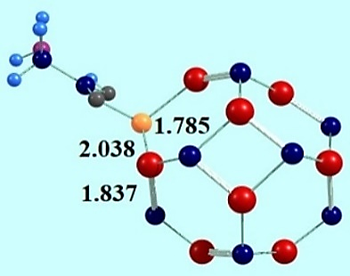 | MODELE-a
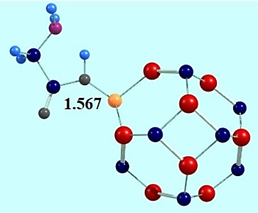 | 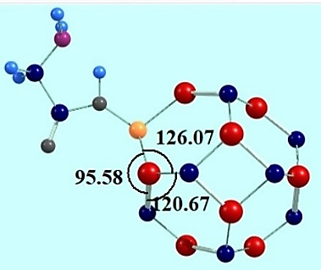 | 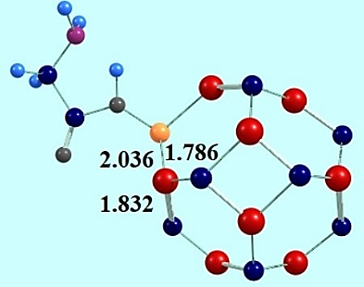 | MODELE-b
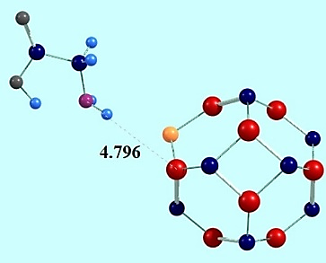 | 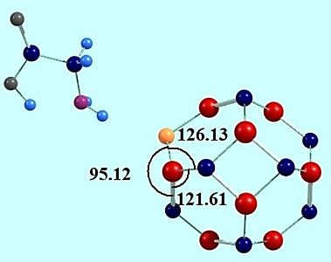 | 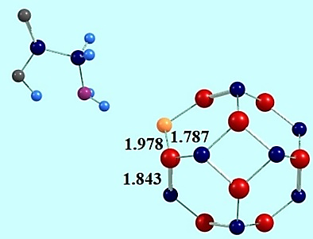 | MODELE-c
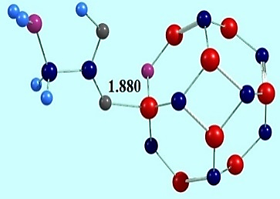 | 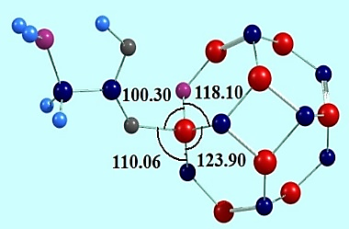 | 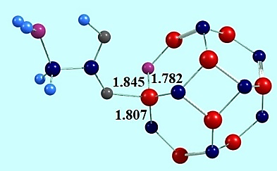 | MODEL F-a
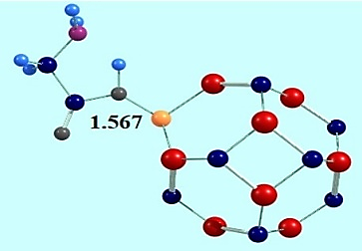 | 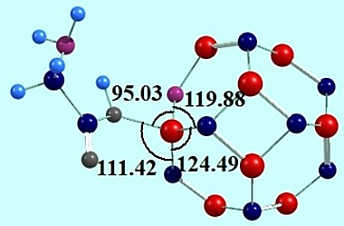 | 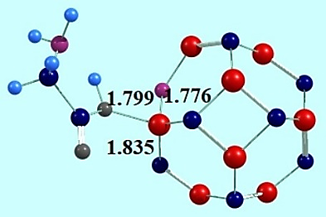 | MODELF-b
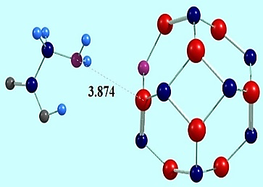 | 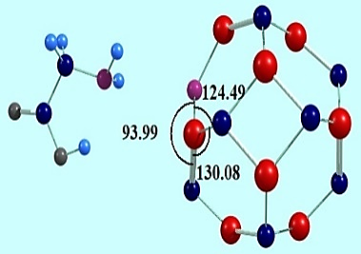 | 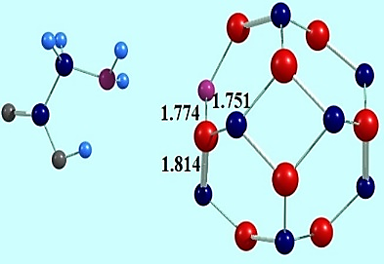 | MODELF-c

Table S1 The thermodynamic parameters of solvent (water) effect for A-a to F-a models
∆∆G(sol)water kcal/mol | ∆G kcal/mol | Model
+3.93 | -24.20 | A-a
+0.34 | -27.61 | B-a
+13.02 | -20.23 | C-a
+10.06 | -23.22 | D-a
+4.96 | -27.60 | E-a
+4.07 | -30.01 | F-a

Table S2 Quantum parameters for adsorption of glycine on the surface of pristine and N,B doped C12Si12 for A-a to F-c models
Pristine | MODEL B-c | MODEL B-b | MODEL B-a | property
-6.03 | -5.69 | -5.34 | -5.36 | E HOMO(ev)
-2.80 | -2.44 | -2.14 | -2.20 | E LUMO(ev)
+3.23 | +3.25 | +3.20 | +3.16 | E gap
-4.42 | -4.07 | -3.74 | -3.78 | E Fermi
+2.80 | +2.44 | +2.14 | +2.20 | A
+6.03 | +5.69 | +5.34 | +5.36 | I
+1.61 | +1.62 | +1.60 | +1.58 | η
+0.30 | +0.30 | +0.31 | +0.31 | S
-4.42 | -4.07 | -3.74 | -3.78 | µ
-1.61 | -1.62 | -1.6 | -1.58 | ∆ф
+2.73 | +2.50 | +2.33 | +2.38 | ∆N
+9.77 | +5.09 | +4.37 | +4.51 | ω
+4.42 | +4.07 | +3.74 | +3.78 | X

ristine | MODEL B-c | MODEL B-b | MODEL B-a | property
-6.03 | -5.83 | -5.33 | -5.13 | E HOMO(ev)
-2.80 | -2.61 | -2.12 | -2.15 | E LUMO(ev)
+3.23 | +3.22 | +3.20 | +2.97 | E gap
-4.42 | -4.22 | -3.72 | -3.64 | E Fermi
+2.80 | +2.61 | +2.12 | +2.15 | A
+6.03 | +5.83 | +5.33 | +5.13 | I
+1.61 | +1.61 | +1.60 | +1.49 | η
+0.30 | +0.31 | +0.31 | +0.33 | S
-4.42 | -4.22 | -3.72 | -3.64 | µ
-1.61 | -1.61 | -1.6 | -1.49 | ∆ф
+2.73 | +2.62 | +2.32 | +2.44 | ∆N
+9.77 | +5.53 | +4.32 | +4.45 | ω
+4.42 | +4.22 | +3.72 | +3.64 | X

MODEL II- β | MODEL II-α | MODEL  C-c-β | MODEL  C-c-α | MODEL  C-b-β | MODEL C-b-α | MODEL  C-a-β | MODEL  C-a-α | property
-5.50 | -5.67 | -5.62 | -5.73 | -5.01 | -5.15 | -4.98 | -5.10 | EHOMO(ev)
-4.42 | -2.92 | -4.34 | -2.77 | -3.64 | -2.22 | -3.81 | -2.32 | ELUMO(ev)
+1.08 | +2.75 | +1.28 | +2.96 | +1.36 | +2.93 | +1.16 | +2.78 | E gap
-4.96 | -4.29 | -4.98 | -4.25 | -4.32 | -3.68 | -3.94 | -3.71 | E Fermi
+4.42 | +2.92 | +4.34 | +2.77 | +3.64 | +2.22 | +3.81 | +2.32 | A
+5.50 | +5.67 | +5.62 | +5.73 | +5.01 | +5.15 | +4.98 | +5.10 | I
+0.54 | +1.37 | +0.64 | +1.48 | +0.68 | +1.46 | +0.58 | +1.39 | η
+0.92 | +0.72 | +0.77 | +0.33 | +0.73 | +0.34 | +0.85 | +0.35 | S
_4.96 | -4.29 | -4.98 | -4.25 | -4.32 | -3.68 | -4.39 | -3.71 | µ
-0.54 | -1.37 | -0.64 | -1.48 | -0.68 | -1.46 | -0.58 | _1.39 | ∆ф
+9.18 | +3.13 | +7.77 | +2.87 | +6.34 | +2.51 | +7.54 | +2.67 | ∆N
+22.77 | +13.43 | +19.36 | +6.10 | +13.73 | +4.63 | +16.59 | +2.97 | ω
+4.29 | +4.29 | +4.98 | +4.25 | +4.32 | +3.68 | +4.39 | +3.71 | X

MODEL IV- β | MODEL IV-α | MODEL  D-c-β | MODEL  D-c-α | MODEL  D-b-β | MODEL  D-b-α | MODEL  D-a-β | MODEL  D-a-α | property
-5/82 | -4/79 | -6.13 | -5.16 | -5.70 | -4.93 | -4.97 | -4.66 | E _{HOMO(ev)}
-3/28 | -3/07 | -3.61 | -3.37 | -3.25 | -2.99 | -2.70 | -2.58 | E _{LUMO(ev)}
+2/53 | +1/71 | +2.51 | +1.79 | +2.45 | +1.93 | +2.27 | +2.08 | E _{gap}
-4/55 | -3/93 | -4.87 | -4.27 | -4.48 | -3.96 | +4.97 | -2.62 | E _{Fermi}
+3/28 | +3/07 | +3.61 | +3.37 | +3.25 | +2.99 | +2.70 | +2.58 | A
+5/82 | +4/79 | +6.13 | +5.16 | +5.70 | +4.93 | +4.97 | +4.66 | I
+1/26 | +0/85 | +1.25 | +0.89 | +1.22 | +0.96 | +1.13 | +1.04 | η
+0/39 | +0/58 | +0.39 | +0.55 | +0.48 | +0.51 | +0.44 | +0.48 | S
-4/55 | -3/93 | -4.87 | -4.27 | -4.48 | -3.96 | -3.83 | -2.62 | µ
_1/26 | +0/85 | -1.25 | -0.89 | -1.22 | -0.96 | -1.13 | -1.04 | ∆ф
+3/59 | +4/57 | +3.87 | +4.75 | +3.65 | +4.08 | +3.38 | +2.51 | ∆N
+8/19 | +9/00 | +9.45 | +10.16 | +8.19 | +5.10 | +6.47 | +5.44 | ω
+4/55 | +3/93 | +4.87 | +4.27 | +4.48 | +3.96 | -3.83 | +2.26 | X

MODEL I-β | MODEL I-α | MODEL  E-c-β | MODEL  E-c-α | MODEL  E-b-β | MODEL  E-b-α | MODEL  E-a-β | MODEL  E-a-α | property
-5.82 | -5.75 | -6.04 | -6.07 | -5.05 | -4.28 | -4.92 | -4.09 | EHOMO(ev)
-3.93 | -2.82 | -4.29 | -3.07 | -2.65 | -2.35 | -2.48 | -2.32 | E LUMO(ev
1.88 | 2.93 | +1.75 | +2.99 | +2.39 | +1.92 | +2.44 | +1.77 | E gap
-4.87 | -4.28 | -5.17 | -4.57 | -3.85 | -3.31 | -3.70 | -3.21 | E Fermi
3.93 | 2.82 | +4.29 | +3.07 | +2.65 | +2.35 | +2.48 | +2.32 | A
5.82 | 5.75 | +6.04 | +6.07 | +5.05 | +4.28 | +4.92 | +4.09 | I
0.94 | 1.46 | +0.87 | +1.50 | 1.19 | +0.96 | +1.22 | +0.88 | η
0.52 | 0.34 | +0.57 | +0.33 | 0.41 | +0.51 | +0.40 | +0.56 | S
-4.87 | -4.28 | -5.17 | -4.57 | -3.85 | -3.31 | -3.70 | -3.21 | µ
-0.94 | -1.46 | -0.87 | -1.50 | -1.19 | -0.96 | -1.22 | -0.88 | ∆ф
5.16 | 2.92 | +5.90 | +3.04 | +3.21 | +3.45 | +3.03 | +3.62 | ∆N
12.61 | 6.26 | +15.26 | +6.97 | +6.18 | +5.70 | +5.62 | +5.81 | ω
4.87 | 4.28 | +5.17 | +4.57 | +3.85 | +3.31 | +3.70 | +3.21 | X

MODEL III-β | MODEL III-α | MODEL  F-c-β | MODEL  F-c-α | MODEL  F-b-β | MODEL  F-b-α | MODEL  F-a-β | MODEL  F-a-α | property
-5.82 | -5.42 | -6 | -5.62 | -5.21 | -4.80 | -4.93 | -4.02 | E HOMO(e
-3.15 | -2.86 | -3.32 | -3.04 | -2.53 | -2.13 | -2.45 | -2.45 | E LUMO(ev
2.67 | 2.55 | +2.67 | +2.57 | +2.68 | +2.67 | +2.48 | +1.57 | E gap
-4.48 | -4.14 | -4.66 | -4.33 | -3.87 | -3.46 | -3.69 | -3.23 | E Fermi
3.15 | 2.86 | +3.32 | +3.04 | +2.53 | +2.13 | +2.45 | +0.63 | A
5.82 | 5.42 | +6 | +5.62 | +5.21 | +4.80 | +4.93 | +4.02 | I
1.33 | 1.27 | +1.33 | +1.28 | +1.33 | +1.33 | +1.24 | +2.45 | η
0.37 | 0.39 | +0.37 | +0.38 | +0.37 | +0.37 | +0.40 | +0.63 | S
-4.48 | -4.14 | -4.66 | -4.33 | -3.87 | -3.46 | -3.69 | -3.23 | µ
-1.33 | -1.27 | -1.33 | -1.28 | -1.33 | -1.33 | -1.24 | -0.78 | ∆ф
3.35 | 3.24 | +3.49 | +3.36 | +2.89 | +2.59 | +2.97 | +4.14 | ∆N
7.53 | 6.72 | +8.14 | +7.29 | +5.61 | +4.50 | +5.49 | +6.66 | ω
4.48 | 4.14 | +4.66 | +4.43 | +3.87 | +3.46 | +3.69 | +3.23 | X

Table S3 Comparison of energy of donor-acceptor orbital for A-a to F-c models
F(i,j) | E_{(j)}-E_{(i)} |  |  | E²_{(Kcal/mol)} |  | Acceptor(j) | Donor(i) |  | Structure
0.078 |  | 0.76 | 9.98 |  | σ*Si1 - C13 |  |  | Si5 - C16 |  | Model A-a
0.057 |  | 0.72 | 5.63 |  | σ*Si3 – C14 |  |  | σSi5 - C16
0.025 |  | 0.72 | 1.05 |  | σ*Si5 -C16 |  |  | σSi5 - C16
0.077 |  | 0.76 | 9.77 |  | σ*Si1- C13 |  |  | σSi5 - C18
0.016 |  | 0.53 | 0.53 |  | π*Si9 - C18 |  |  | σSi5 - C18
0.055 |  | 0.79 | 5.18 |  | σ*Si9 - C20 |  |  | σSi5 - C18
0.018 |  | 0.80 | 0.52 |  | σ*Si1- C13 |  |  | σSi5 - C24
0.045 |  | 0.77 | 3.34 |  | σ*Si5 - C16 |  |  | σSi5 - C24
0.039 |  | 0.73 | 2.39 |  | σ*Si5-C18 |  |  | σSi5 - C24
0.079 |  | 0.75 | 10.40 |  | σ*Si1-C13 |  |  | σSi5 - C16 |  | Model A-b
0.023 |  | 0.72 | 5.22 |  | σ*Si3 - C14 |  |  | σSi5 - C16
0.023 |  | 0.72 | 0.91 |  | σ*Si5 - C16 |  |  | σSi5 - C16
0.079 |  | 0.76 | 10.42 |  | σ*Si1 - C13 |  |  | σSi5 - C18
0.020 |  | 0.77 | 0.87 |  | σ*Si5 - C18 |  |  | σSi5 - C18
0.016 |  | 0.52 | 0.58 |  | π*Si9 - C18 |  |  | σSi5 - C18
0.018 |  | 0.80 | 0.51 |  | σ*Si1- C13 |  |  | σSi5 - C24
0.045 |  | 0.77 | 3.22 |  | σ*Si5- C16 |  |  | σSi5 - C24
0.055 |  | 0.73 | 0.62 |  | σ*Si8 - C23 |  |  | σSi5 - C24
0.079 |  | 0.76 | 10.25 |  | σ*Si1 - C13 |  |  | σSi5 - C16 |  | Model A-c
0.057 |  | 0.76 | 5.35 |  | σ*Si3 - C16 |  |  | σSi5 - C16
0.016 |  | 0.53 | 0.54 |  | π*Si3 - C16 |  |  | σSi5 - C16
0.079 |  | 0.76 | 10.23 |  | σ*Si1- C13 |  |  | σSi5 - C18
0.024 |  | 0.73 | 0.99 |  | σ*Si5 - C18 |  |  | σSi5 - C18
0.016 |  | 0.53 | 0.57 |  | π*Si9 - C18 |  |  | σSi5 - C18
0.018 |  | 0.81 | 0.51 |  | σ*Si1 - C13 |  |  | σSi5 - C24
0.019 |  | 0.78 | 3.02 |  | σ*Si6 - C24 |  |  | σSi5 - C24
0.043 |  | 0.78 | 0.59 |  | σ*Si8 -C23 |  |  | σSi5 - C24

F(i,j) | E_{(j)}-E_{(i)} | E²_{(Kcal/mol)} |  |  | Acceptor(j) | Donor(i) | Structure
0.042 | 0.79 | 2.74 |  | σ*Si1-C16 |  | σSi1-C13 | Model B-a
0.045 | 0.78 | 3.28 |  | σ*Si2-C13 |  | σSi1-C13
0.022 | 0.81 | 0.75 |  | σ*Si2-C14 |  | σSi1-C13
0.021 | 0.73 | 0.78 |  | σ*Si1– C16 |  | σSi1-C16
0.055 | 0.72 | 5.29 |  | σ*Si3-C15 |  | σSi1-C16
0.077 | 0.76 | 9.95 |  | σ*Si5-C24 |  | σSi1-C16
0.020 | 0.75 | 0.87 |  | n*Si1 |  | σSi1-C18
0.078 | 0.72 | 1.00 |  | σ*Si1-C18 |  | σSi1-C18
0.024 | 0.50 | 10.11 |  | σ*Si5-C24 |  | σSi1-C18
0.046 | 0.78 | 3.36 |  | σ*Si1-C18 |  | σSi1-C13 | Model B-b
0.045 | 0.78 | 0.52 |  | σ*Si2-C19 |  | σSi1-C13
0.018 | 0.79 | 3.24 |  | σ*Si12-C13 |  | σSi1-C13
0.022 | 0.73 | 0.85 | σ*Si1-C16 |  |  | σSi1-C16
0.055 | 0.72 | 5.45 | σ*Si3-C15 |  |  | σSi1-C16
0.078 | 0.76 | 9.94 | σ*Si5-C24 |  |  | σSi1-C16
0.023 | 0.72 | 0.88 | σ*Si1-C18 |  |  | σSi1-C18
0.077 | 0.72 | 9.87 | σ*Si5-C24 |  |  | σSi1-C18
0.056 | 0.76 | 5.15 | σ*Si9-C21 |  |  | σSi1-C18
0.053 | 0.76 | 4.65 | σ*Si1-C18 |  |  | σSi1-C13 | Model B-c
0.016 | 0.50 | 0.54 | π*Si11-C19 |  |  | πSi1-C13
0.087 | 0.28 | 33.64 | π*Si12-C20 |  |  | πSi1-C13
0.017 | 0.71 | 0.51 | σ*Si1-C16 |  |  | σSi1-C16
0.048 | 0.74 | 3.88 | σ*Si3–C16 |  |  | σSi1-C16
0.064 | 0.74 | 6.87 | σ*Si5-C24 |  |  | σSi1-C16
0.018 | 0.71 | 3.41 | σ*Si1-C16 |  |  | σSi1-C18
0.061 | 0.74 | 0.55 | σ*Si1-C18 |  |  | σSi1-C18
0.044 | 0.70 | 6.26 | σ*Si5-C24 |  |  | σSi1-C18

F(i,j) | E_{(j)}-E_{(i)} |  | E²_{(Kcal/mol)} |  |  | Acceptor(j) | Donor(i) |  | Structure
0.059 |  | 0.77 |  | 2.89 | σ*Si1–C12 |  |  | σC17–B34 | Model C-a
0.049 |  | 0.74 |  | 2.02 | σ*Si3–C15 |  |  | σC17–B34
0.025 |  | 1.00 |  | 0.37 | σ*C24–C25 |  |  | σC17–B34
0.041 |  | 0.83 |  | 1.07 | σ*C24–C25 |  |  | σC25–B34
0.018 |  | 0.45 |  | 0.39 | σ*C25– B34 |  |  | σC25–B34
0.062 |  | 0.53 |  | 3.40 | n*B34 |  |  | σSi5–C23
0.035 |  | 1.07 |  | 0.55 | n*B34 |  |  | σC24–O26
0.068 |  | 0.77 |  | 3.72 | σ*Si1– C12 |  |  | σC15–B34 | Model C-b
0.051 |  | 0.55 |  | 2.75 | π*Si1–C12 |  |  | σC15–B34
0.027 |  | 0.73 |  | 0.63 | σ*Si1–C17 |  |  | σC15–B34
0.058 |  | 0.51 |  | 3.29 | n*B34 |  |  | σC17–B34
0.067 |  | 0.77 |  | 3.67 | σ*Si1–C12 |  |  | σC17–B34
0.025 |  | 0.93 |  | 0.42 | σ*C23–B34 |  |  | σC17–B34
0.020 |  | 0.82 |  | 0.29 | σ*Si1–C12 |  |  | σC23–B34
0.055 |  | 0.64 |  | 2.62 | π*Si5–C14 |  |  | σC23–B34
0.045 |  | 0.59 |  | 1.97 | π*Si7–C20 |  |  | σC23–B34
0.027 |  | 0.72 |  | 0.60 | σ*Si1–C17 |  |  | σC15–B34 | Model C-c
0.044 |  | 0.72 |  | 1.64 | σ*Si3–C13 |  |  | σC15–B34
0.049 |  | 0.75 |  | 2.05 | σ*Si3–C15 |  |  | σC15–B34
0.017 |  | 0.57 |  | 0.26 | n*B34 |  |  | σC17–B34
0.020 |  | 0.86 |  | 3.15 | σ*Si1–C12 |  |  | σC17– B34
0.021 |  | 0.88 |  | 0.30 | σ*C23–B34 |  |  | σC17– B34
0.025 |  | 0.74 |  | 0.52 | σ*Si1–C15 |  |  | σC23–B34
0.038 |  | 0.76 |  | 1.17 | σ*Si5–C23 |  |  | σC23–B34
0.062 |  | 0.76 |  | 0.30 | σ*C17–B34 |  |  | σC23–B34

F(i,j) | E_{(j)}-E_{(i)} |  | E²_{(Kcal/mol)} |  |  | Acceptor(j) | Donor(i) | Structure
0.066 |  | 0.38 |  | 6.55 | π*Si3-C13 |  | πC15-N34 | Model D-a
0.060 |  | 0.25 |  | 6.00 | π*C15-N 34 |  | πC15-N34
0.018 |  | 0.68 |  | 0.29 | σ*C17-N 34 |  | πC15-N34
0.056 |  | 1.01 |  | 1.87 | σ*Si3-C15 |  | σC17-N34
0.029 |  | 1.01 |  | 0.51 | σ*Si8-C17 |  | σC17-N34
0.052 |  | 1.17 |  | 1.43 | σ*C23-N34 |  | σC17-N34
0.022 |  | 1.08 |  | 0.26 | σ*Si3- C15 |  | σC23-N34
0.044 |  | 1.19 |  | 1.28 | σ*C15-N 34 |  | σC23-N34
0.049 |  | 1.17 |  | 1.03 | σ*C17- N 34 |  | σC23-N34
0.020 |  | 0.93 |  | 0.26 | σ* Si3- C13 |  | σC23-N34 | Model D-b
0.049 |  | 0.89 |  | 1.65 | σ* Si7- C23 |  | σC15 - N34
0.054 |  | 1.07 |  | 1.89 | σ* Si8- C17 |  | σC15-N34
0.047 |  | 0.94 |  | 1.43 | σ*Si1- C12 |  | σC17- N34
0.021 |  | 0.93 |  | 0.29 | σ*Si1- C17 |  | σC17-N34
0.047 |  | 0.91 |  | 1.52 | σ*Si5- C 23 |  | σC17-N34
0.025 |  | 0.99 |  | 0.37 | σ*Si1- C15 |  | σC23-N34
0.023 |  | 1.03 |  | 0.51 | σ*Si1- C17 |  | σC23-N34
0.029 |  | 0.93 |  | 0.31 | σ*Si5- C14 |  | σC23-N34
0.020 |  | 0.94 |  | 0.50 | σ*Si3- C15 |  | σC15-N34 | Model D-c
0.028 |  | 0.94 |  | 1.80 | σ*Si8- C17 |  | σC15-N34
0.053 |  | 1.01 |  | 0.28 | σ*C17- N 34 |  | σC15-N34
0.021 |  | 0.96 |  | 1.71 | σ*Si3- C15 |  | σC17-N34
0.052 |  | 0.91 |  | 1.48 | σ*Si5- C23 |  | σC17-N34
0.047 |  | 1.01 |  | 0.26 | σ*C15- N 34 |  | σC23-N34
0.020 |  | 1.07 |  | 0.25 | σ*Si5 - C14 |  | σC23-N34

F(i,j) | E_{(j)}-E_{(i)} | E²_{(Kcal/mol)} |  | Acceptor(j) | Donor(i) | Structure
0.065 | 0.65 | 3.97 | σ*Si1-C13 |  | σSi5-B34 | Model E-a
0.051 | 0.66 | 2.42 | σ*Si5-C23 |  | σSi5-B34
0.016 | 0.62 | 0.25 | σ*Si6- C22 |  | σSi5-B34
0.038 | 0.38 | 2.15 | n*B34 |  | σSi3-B34
0.046 | 0.39 | 3.24 | σ*Si1-C13 |  | σSi3-B34
0.016 | 0.58 | 0.27 | σ*Si5– C17 |  | σSi3-B34
0.063 | 0.61 | 0.58 | σ*Si3-C15 |  | σSi1-B34
0.022 | 0.66 | 3.73 | σ*Si5-C23 |  | σSi1-B34
0.025 | 0.64 | 0.47 | σ*Si5-B34 |  | σSi1-B34
0.026 | 0.64 | 2.56 | σ*Si3-C15 |  | σSi1-B34 | Model E-b
0.030 | 0.44 | 0.59 | σ*Si5-C17 |  | σSi1-B34
0.063 | 0.66 | 4.34 | σ*Si5-C23 |  | σSi1-B34
0.042 | 0.38 | 3.14 | n*B34 |  | σSi3-B34
0.051 | 0.41 | 2.88 | π*Si1-C13 |  | σSi3-B34
0.018 | 0.67 | 0.25 | σ*Si4-C16 |  | σSi3-B34
0.064 | 0.66 | 4.53 | σ*Si1-C13 |  | σSi5-B34
0.019 | 0.66 | 0.29 | σ*Si1-B34 |  | σSi5-B34
0.048 | 0.61 | 1.47 | σ*Si5-C23 |  | σSi5-B34
0.051 | 0.62 | 2.56 | σ*Si3-C15 |  | σSi1-B34 | Model E-c
0.025 | 0.63 | 0.59 | σ*Si3-B34 |  | σSi1-B34
0.067 | 0.65 | 4.34 | σ*Si5-C23 |  | σSi1-B34
0.058 | 0.68 | 3.14 | σ*Si3 - C14 |  | σSi3- B34
0.055 | 0.65 | 2.88 | σ*Si3 - C15 |  | σSi3- B34
0.017 | 0.71 | 0.25 | σ*Si4 -C16 |  | σSi3- B34
0.039 | 0.65 | 4.53 | σ*Si1- C13 |  | σSi5 - B34

F(i,j) | E_{(j)}-E_{(i)} |  | E²_{(Kcal/mol)} |  | Acceptor(j) | Donor(i) | Structure
0.188 | 0.86 | 3.28 |  | n*Si1 |  | σSi8-N34 | Model F-a
0.023 | 1.03 | 0.33 |  | σ*Si8-N34 |  | σSi8-N34
0.081 | 0.40 | 9.90 |  | π*Si1-C12 |  | nN34
0.038 | 0.42 | 1.99 |  | π*Si1-C12 |  | nN34
0.048 | 0.60 | 2.11 |  | σ*Si1-C32 |  | nN34
0.063 | 0.35 | 2.82 |  | π*Si8-C17 |  | nN34
0.057 | 0.53 | 3.39 |  | σ*Si8-C17 |  | nN34
0.015 | 0.39 | 0.35 |  | π*Si8– C17 |  | nN34
0.204 | 0.87 | 27.69 |  | n*Si3 |  | σSi1-N34 | Model F-b
0.022 | 1.01 | 0.29 |  | σ*Si3- C14 |  | σSi1-N34
0.071 | 0.37 | 7.98 |  | n*Si3 |  | nN34
0.069 | 0.43 | 7.55 |  | n*Si3 |  | nN34
0.018 | 0.61 | 0.30 |  | n*Si1-C13 |  | nN34
0.058 | 0.33 | 6.32 |  | n*Si1-C13 |  | nN34
0.019 | 0.39 | 0.56 |  | n*Si1-C13 |  | nN34
0.027 | 0.88 | 52.96 |  | n*Si5 |  | σSi1N34 | Model F-c
0.067 | 0.85 | 3.18 |  | π*Si5-C17 |  | σSi1N34
0.282 | 1.06 | 0.39 |  | σ*Si9-C17 |  | σSi1N34
0.024 | 0.35 | 0.96 |  | n*Si3 |  | nN34
0.059 | 0.29 | 7.63 |  | n*Si3 |  | nN34
0.190 | 0.44 | 51.53 |  | n*Si3 |  | nN34
0.055 | 0.56 | 2.94 |  | σ*Si5-C17 |  | nN34
0.018 | 0.51 | 0.32 |  | σ*Si5-C17 |  | nN34
0.016 | 0.33 | 0.47 |  | σ*Si5-C17 |  | nN34

Table S4The NBO and Milliken charge around Glycine for A-a to F-c models
∆P NBO | ∆P Muliken | Model | ∆P NBO | ∆P Muliken | Model
+0.216 | +0.320 | D-a | +0.213 | +0.319 | A-a
-0.503 | -0.181 | D-b | +0.185 | +0.269 | A-b
-0.005 | -0.016 | D-c | +0.207 | +0.288 | A-c
+0.307 | +0.325 | E-a | +0.222 | +0.333 | B-a
+0.306 | +0.334 | E-b | +0.184 | +0.363 | B-b
+0.007 | +0.005 | E-c | +0.171 | +0.269 | B-c
+0.212 | +0.338 | F-a | +0.307 | +0.269 | C-a
+0.193 | +0.289 | F-b | +0.215 | +0.327 | C-b
+0.010 | +0.025 | F-c | -0.237 | -0.157 | C-c

